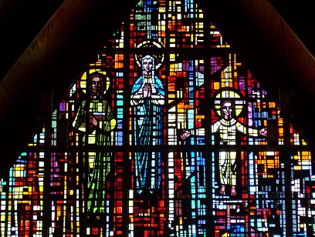

THE MAIN WINDOW -- THE HOLY FAMILY
The Façade Window is 32 feet wide by 28 feet high, one of the largest
faceted glass windows in the Pittsburgh Area.

Joseph, the head of the family, robed in green represents the sovereignty
of the “father-role” in family life. The maternal image of woman is
symbolized by the figure of the Virgin Mary, robed in blue. The Child, with
arms outstretched, robed in white recalls the Messianic Role of Christ while
still obedient to His earthly parents

